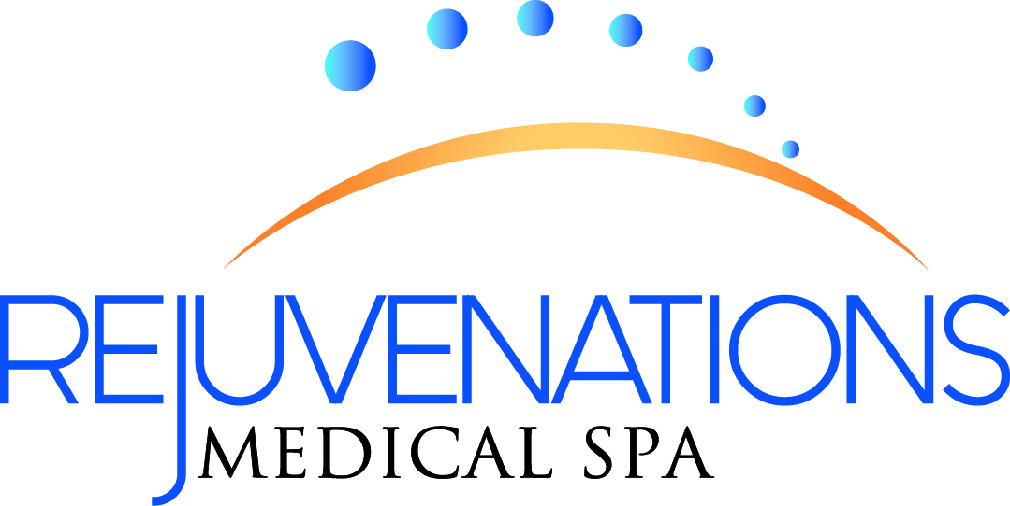

Name | Birthdate
Street Address | City, State, Zip
Email (for monthly specials) | Sex  Female Male
Please only note phone numbers that we may call for appointment reminders.
Home Phone
Business Phone
Cell Phone

What skin issues or treatments are you here to talk about?___ _________ ______

How did you hear about Rejuvenations Medical Spa?____________ ________________
(Any referrals are given a $25.00 spa referral credit)
Any Allergies? (Eggs, Soy, Food, Sulfa, drugs etc…)_____________________________
Would you like a free Permanent make-up consultation today? _______________ __
Please list all medications you take regularly (include hormones, vitamins, etc….)
____________________________________________________ _________
Do you wear contact lenses? Yes /No
Are you a smoker? Yes /No
Do you take aspirin or Coumadin regularly? Yes / No
Have you had any prior facial cosmetic surgeries? ____________________ ____________

Within the last six months, have you taken or used the following? (Please circle)
Retin-A Tazarac Accutane Diuretics
Antibiotics Laxatives Alpha Hydroxy Acids Date of last dose______

Please circle any health conditions which you have had in the past or are currently experiencing. (Please circle)
Cold Sores Hemophilia Pregnancy
Asthma Epilepsy Nursing
Heart Problems Diabetes Dermatomyocitis
Thyroid Disease Hysterectomy Hepatitis
Cancer Hypoglycemia Phlebitis
High/Low Blood Pressure Pacemaker Hormonal Disorders

Other:__________________________________________________________

I am fully aware that my condition is of a cosmetic concern. I understand that no guarantee can be given as to the final result obtained. Please note a “flare up” or worsening of the condition may occur before the skin begins to look better. The infection is escaping from below the surface of the skin now that the follicles are cleared. With Rejuvenations Medical Spa treatments, your skin will be restored to a more healthful condition.

Signature_______________________________________________ Date_______

